

Curriculum Policy

We are ‘seeds sown in the good soil’
(Matthew 13:23)

Adopted:

Approved by Governors:

Review date:

Aims and Objectives
At Orford CoE Primary School, we have designed a curriculum with the following aims and objectives for our pupils:
Being - For pupils to value themselves as unique, special individuals, to know they have a right to be in relationships which ensure they are happy and safe and be confident that they can meet challenges and barriers and overcome them.
Belonging - For pupils to understand that they are part of a family, community, region, country and world, to provide meaningful opportunities for them to explore that idea and to help them recognise that they can make a significant contribution to those places through their actions, words and ambitions.
Growing - For pupils to understand that their life is a learning journey marked by important milestones, that making good use of opportunities and experiences will help them become the person they want to be and that the skills and knowledge they learn in primary school will benefit their future.
Experimenting - For pupils to understand that through questioning, taking risks, curiosity and sharing their ideas with others they can open doors to wider opportunities. For pupils to understand that their passions and interests may be the foundation of their future and should be valued, nurtured and developed.
These aims and objectives are detailed in our intent plan which sets out our ambitions for ensuring pupils at thrive and flourish at each stage of our curriculum (see appendix 1)
Curriculum Content and Sequencing
At Orford CoE Primary School, our curriculum is based on the September 2014 National Curriculum for Key Stages 1 & 2 and the Early Years 2024 framework in Reception.

National Curriculum Subjects and Time Dedication

Morning Sessions  8:30 - 10.15 = 105 mins a day  10:45 - 11:45 = 60 mins a day  13.75 hours a week |  |  | Weekly allocations
KS 2 English - Writing inc explicit SPAG | 60 mins daily, 40 minutes spelling, 20 minutes handwriting |  | 6 hours
KS2 Reading - whole class teach | 30 mins x3 week |  | 1.5 hours
EYFS/ KS1 Phonics | 30-40 mins daily |  | 3.3 hours
EYFS/ KS1 writing | 30 mins daily |  | 2.5 hours
EYFS/ KS1 Reading | 30 mins x a week Little Wandle reading and/or fluency programme |  | 1.5 hours
Maths Lesson | 1 hour a day |  | 5 hours
10:15 - 10:30 Collective worship daily (8:45 Friday) |  |  | 1.25 hours
KS2 total morning allocations | 13.75 hours
KS 1 total morning allocations | 13.55 hours (below allocation)
Afternoon Sessions 2.25 hours daily 11.25 hours a week |  |  | Weekly allocations
Maths Fluency | 15 mins x 4 a week |  | 1 hour
Science | 1 hour weekly |  | 1
History/Geography | 1 hour weekly |  | 1
Art /DT | 1 hour weekly |  | 1
French | 45 minutes weekly |  | 0.75
RE | 1 hour a week |  | 1
PE | 2 hours |  | 2
Music | 45 minutes weekly (KS1) 1 hour weekly (KS2) |  | 1
PSHE | 40 mins a week |  | 0.66
Computing | 1 hour a week |  | 1
MfL | 40 minutes (KS1) 45 minutes (KS2) |  | 0.75
Rolling Programme
. Our curriculum is based on a 2-3 year cycle rolling programme. This ensures children in classes of mixed year groups follow the national curriculum and that learning builds progressively towards the end of Year 6
. Curriculum maps are grouped and planned for as Y1, Y2, Y3/Y4 (Lower KS2) and 5/6 (Upper KS2).
. Children may encounter subjects in a different year group (e.g. year 4 science when they are in year 3) but they will have completed the whole curriculum by the time they leave year 6, in a scaffolded and timely manner.
Curriculum Maps
. Long Term Plans for all subjects for Y1-6 are organised into units by year group, known as curriculum maps (Appendix 2)
. All curriculum maps identify the key learning of each unit
. The yearly plan and rolling programme indicate which year group and units each class should focus on each year. The programme is based on a spiral model with all key ideas being revisited and built on at regular intervals through each key stage and class.
. Wherever possible themes are dovetailed across the curriculum, to create extra opportunities to embed knowledge and skills, this includes linking to key areas in the EYFS curriculum where appropriate.

Knowledge Organisers
. Knowledge organisers support medium term planning. They identify prior knowledge and skills, new knowledge and skills and key vocabulary that must form the backbone of the learning in that unit. Some have been written by subject leaders, others have been selected from published schemes of work. Each organiser also identifies how the unit links to the school’s intentions of Being, Belonging, Growing, Experimenting (Appendix 3)
. Knowledge organisers distill and clarify the building blocks for learning in each subject ready to extend in classroom learning. They do not replace other lesson planning resources but make it explicit what pupils need to know automatically and be able to apply and develop in lessons.
Learning
. Should be planned before each session in a format that works for individual teachers and classes. Example planning templates can be found in the Curriculum folder.
. Must always be based on robust assessment, identify the main learning and activities for all children in the class, including those with additional needs.
. Must reflect the curriculum overviews and use the knowledge organisers or published scheme as a backbone for learning and practising knowledge and skills
. Should include short and long term memory strategies to ensure knowledge embeds and generative knowledge is fostered.
. All classroom staff should be given a copy of short term planning and their role clearly identified and understood before each lesson begins
EYFS
Please see separate Early Years and Foundation Stage Policy for information and details of the early years curriculum at Orford CoE Primary School and Nursery.
Enrichment and Entitlement
Extended Curriculum
At Orford CoE, we have extended the curriculum to include additional provision in the following areas.

Current Affairs
Daily Newsround KS1 & KS2 alongside opportunities to discuss key world events.
Teaching Kitchen Garden Project
Aims:
· To link pupil’s education to the local economic and employment picture
· To provide meaningful context for learning and practising skills in Maths, Literacy, Science, PSHE and Food technology.
· To provide excellence in food technology education
· To teach pupils about healthy eating and develop good eating behaviours and habits.
· To foster an understanding of food production and distribution and its contribution to the economy and its impact on the environment.
· To foster an attitude of responsibility for the environment and a sense of wellbeing.
Provision:
Pupils are provided with the opportunity once every three weeks to prepare and cook food in our dedicated teaching kitchen. Class 1 cooks healthy snacks and breakfast or lunch dishes. In Class 2 and 3, pupils cook a two course meal which they serve and eat with their cooking group and additional guests at lunchtimes.
Forest Schools
Aims:
· To foster a passion and connection for being outdoors
· To support a development of a relationship between pupils and the environment
· To promote the holistic development of all those involved, fostering resilient, confident, independent and creative learners
· To offer learners the opportunity to take supported risks appropriate to the environment and to themselves.
· To provide a range of learner-centred processes to create a community for development and learning
Provision:
In Class 1 all pupils have an hours session of learning in forest schools every week. Class 2 and 3 have alternate half termly courses in forest schools throughout the year in sessions of 1 hour. All forest school provision is led by a qualified forest school practitioner following the six principles of forest school education.
Inclusion
As a school we believe that all pupils should receive a broad and balanced curriculum. We work to meet the individual needs of pupils in core subjects but not to the detriment of other curriculum areas.
We ensure pupils access a broad and balanced curriculum by
· Chosen slots in the timetable with care and variation if pupils need to be withdrawn for interventions or additional activities
· Providing an enriched curriculum which gives contextual learning and facilitates additional opportunities for pupils to achieve, explore individual potential in a wider curriculum, challenge themselves and strengthen their sense of self-worth
· Establishing a consistent learning environment and culture which ensures support is given across all subjects in areas such as behaviour, SLCN, reading
· Giving opportunities when possible and appropriate for pupils to pursue group and individual interests
· Providing opportunities for pupils to make choices in selecting strategies and methods which ensure knowledge and understanding is embedded
· Providing a personalised curriculum where relevant and appropriate for individual pupils
· Acknowledging achievements across curriculum (and out of school) in Friday assemblies, celebrating all skills and talents
Roles and Responsibilities
Governors
The governing board will monitor the effectiveness of this policy and hold the headteacher to account for its implementation.The governing board will also ensure that:
· A robust framework is in place for setting curriculum priorities and aspirational targets
· Enough teaching time is provided for pupils to cover the National Curriculum and other statutory requirements
· It fulfils its role in processes to disapply pupils from all or part of the National Curriculum, where appropriate, and in any subsequent appeals
Headteacher
· The headteacher is responsible for ensuring that this policy is adhered to, and that:
· All required elements of the curriculum, and those subjects which the school chooses to offer, have aims and objectives which reflect the aims of the school and indicate how the needs of individual pupils will be met
· The amount of time provided for teaching the required elements of the curriculum is adequate and is reviewed by the governing board
· Where appropriate, the individual needs of some pupils are met by permanent or temporary disapplication from all or part of the National Curriculum
· They manage requests to withdraw children from curriculum subjects, where appropriate
· The school’s procedures for assessment meet all legal requirement
· The governing board is fully involved in decision-making processes that relate to the breadth and balance of the curriculum
· The governing board is advised on whole-school targets in order to make informed decision
· Proper provision is in place for pupils with different abilities and needs, including children with SEN
Subject Leaders
· Establish the purpose, principles and expectations for their subject and communicate these clearly through curriculum design
· Ensure curriculum knowledge and skills are being implemented and assessed correctly in all year groups/classes
· Ensure resources are up to date and relevant to current teaching and learning
· Share their passion, good practice and innovation in their subject area
· Support teachers with subject knowledge and pedagogy to ensure high quality provision
· Attend CPD and network events to update their knowledge and skills and stay abreast of current developments
· Monitor attainment and progress in their subject and act on any concerns
· Invite the views of stakeholders, especially pupils to shape the provision of the subject to the needs of our unique setting
Class Teachers
· Communicate an enthusiasm and interest in all subjects taught
· Follow curriculum plans and knowledge organisers in all subject areas
· Ensure timetabling allows for correct curriculum coverage
· Plan for individual needs and abilities to ensure all children have equal access to curriculum and opportunities to succeed
· Take responsibility and seek support to ensure they have good subject knowledge
· Use appropriate resources and pedagogy to engage children and enhance learning
· Provide regular feedback so children know what they are doing well and what they need to do in order to improve across all subjects
· Ensure other adults in the room are deployed effectively to maximise learning
· Complete regular assessments as detailed in the assessment policy to ensure provision has impact
Monitoring and Review
This policy will be reviewed in June 2025
Appendix 1 - Curriculum intent Map
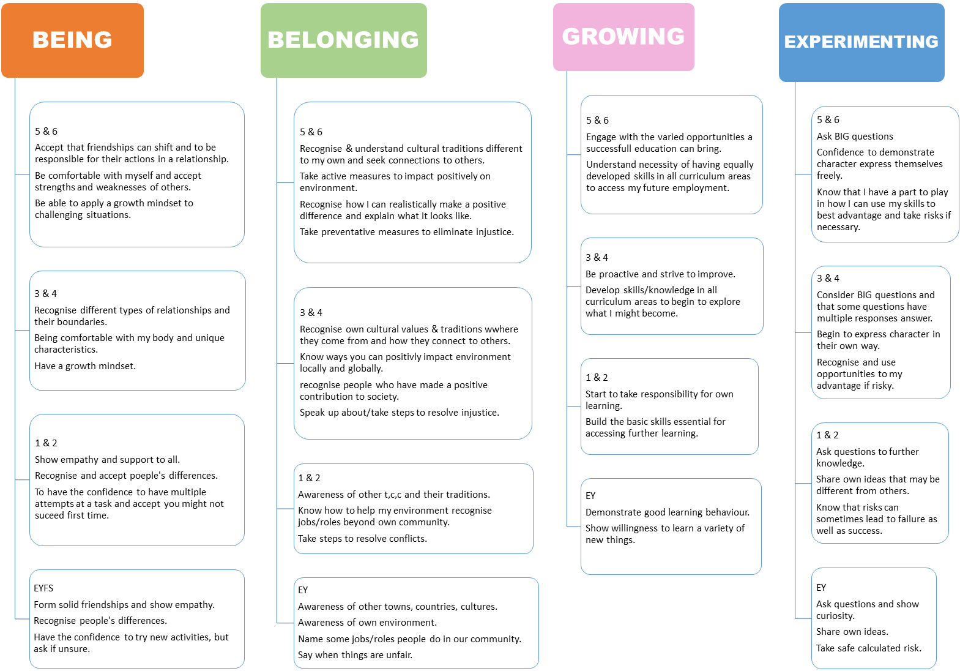
Appendix 2 - Curriculum Subject Map (Sample)
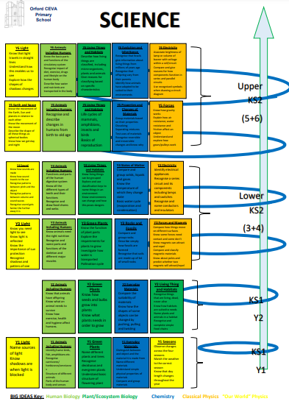

Appendix 3 - Knowledge Organiser (Sample)


