Where do I stand? The Suffolk Agreed Syllabus for RE (2023)
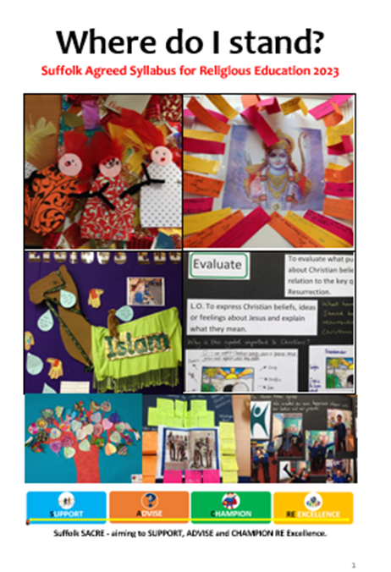
This syllabus applies to all Community and VC schools in Suffolk. It may be adopted by all other Suffolk schools, and by Academies and Free schools anywhere in England. It should be modified by C of E VA schools where required by the Diocesan Schools’ Adviser.
Download: https://suffolklearning.com/wp-content/uploads/2022/09/Suffolk-Agreed-Syllabus-Where-do-I-stand-2023-28.pdf
An agreed syllabus is not a scheme of work. It is a legal document which sets out the current principles and requirements for content and approach in Religious Education.
Schools need to:
- write their own RE scheme based on the principles set out in the Agreed Syllabus and which fulfils it requirements for content and approach
OR
- buy and implement a published RE Scheme e.g. ‘The Emmanuel Project’ or ‘Discovery RE’, mapping it to the Agreed Syllabus to ensure it meets requirements for content and approach, and filling in any gaps
‘The Emmanuel Project’, an RE scheme for Year R to Year 6 was written using the key questions in the Agreed Syllabus and is based on its enquiry cycle approach. The success of this scheme across Suffolk informed the writing of the Agreed Syllabus. It is suitable for all schools and training is available. It is a scheme widely used across the country, sometimes in conjunction with ‘Understanding Christianity’. Details on SACRE Information paper no.3 or directly on https://www.cofesuffolk.org/schools/school-leaders/religious-education/emmanuelproject/ .
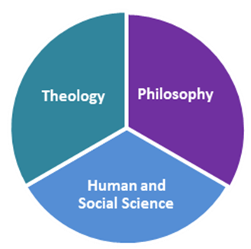
Principles of the Agreed Syllabus
The primary purpose of RE is to develop ‘religious literacy’ or the ‘ability to hold balanced and well-informed conversation about religion and belief’.
‘Where do I stand’ sets out an RE curriculum as a blend of three academic disciplines: theology, philosophy, and human and social science. Each discipline is present at each key stage of learning.
Underpinning these disciplines is a requirement to develop four key attitudes which are essential to good RE learning: Self-awareness, Open-mindedness, Respect for all and Appreciation and wonder.

The Programmes of Study form the statutory basis for designing, or auditing, a scheme of work. They outline requirements at each key stage for:
- Religions and Worldviews – the religions and worldviews to be studied. Christianity is studied at each key stage and other religions and worldviews are included over time.
- Disciplinary Structure – teachers must select or design ENQUIRIES which support discussion of big questions (philosophy) at each key stage, are related to an important belief or concept in a religion or worldview (theology), and include examples of the ‘lived reality’ of individuals or communities in that religion or worldview (human and social science)
- Systematic Enquiries – each enquiry must include opportunities for pupils to: Engage, Enquire, Explore, Evaluate, Express and Extend. Examples of what these mean at each key stage are included.
- Precise Questions – Teachers must frame a ‘rich and precise’ question as a working title for their enquiry, which will direct and clarify the learning to take place. Clear examples of these questions are given or teachers may frame their own.
- Assessment Opportunities – Learning is assessed in relation to the three disciplines. There is no prescribed method of assessment but teachers should choose what is appropriate to drive learning forward and inform reporting to parents.

Non-statutory guidance – the following is included in the syllabus, but further support is available on the SACRE website
Outline schemes of work - For each key stage, non-statutory guidance is given in the form of an outline scheme of work:
- BIG questions are provided to hold together work on individual religions and encourage philosophical debate.
- Key concepts and beliefs are listed so that matters at the heart of each religion and worldview are examined.
- Rich and precise questions are suggested which focus on key concepts and beliefs and clarify what learning is needed

Transition to Key Stage 3 – a guide for the end of primary and the start of KS3
Entitlement to RE 14-19 – detailing what must be provided for students in both Key Stage 4 and 5
SEND – details of provision and access for pupils with SEND
Assessment principles and practice - ideas for how to assess
Resources – details of additional information e.g. possible content to answer the questions on different faiths and worldviews, organisations to help those teaching RE, etc

Training
 | - The Syllabus also includes some sections which the RE Subject Lead or Head of Department may use to deliver training to colleagues.  - It is hoped that these will open up conversations about the nature and purpose of RE and improve the experience of both staff and pupils.

Support
For support implementing the syllabus, contact Suffolk SACRE, or one of the national RE organisations e.g. www.natre.org.uk and for C of E schools, the local Diocesan Schools’ Adviser. In Suffolk, training on the new syllabus is currently offered to all primary schools by the Diocesan Schools’ Adviser, not just church schools.

