

and Nursery

Child Friendly
Child-on-Child Abuse Policy

January 2024
Date Agreed:
Review: Annually


Feeling safe and happy at school
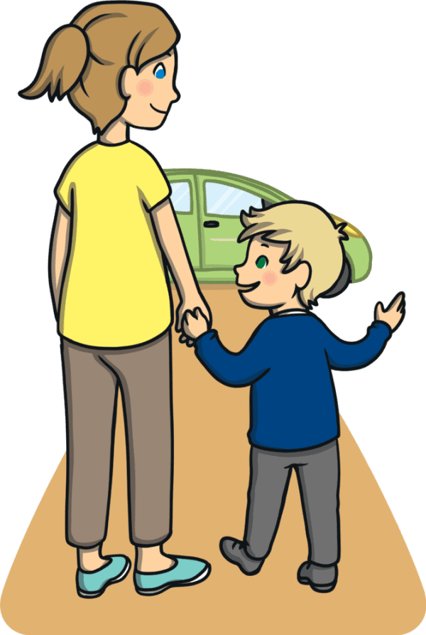
At Orford CofE Primary School, we want to make sure that you feel looked after, safe and happy when you are in and out of school.
Sometimes we don’t know if something bad is happening, so you need to tell us.
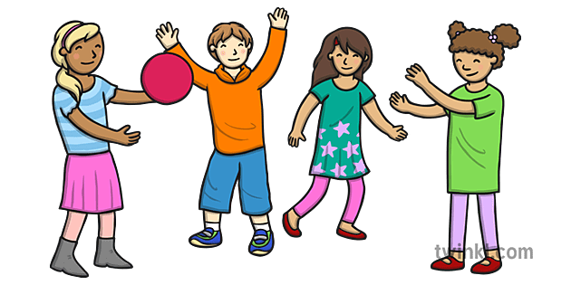
This policy looks at child-on-child abuse is and what you can do when you feel you are being abused, or when you notice someone else being abused.

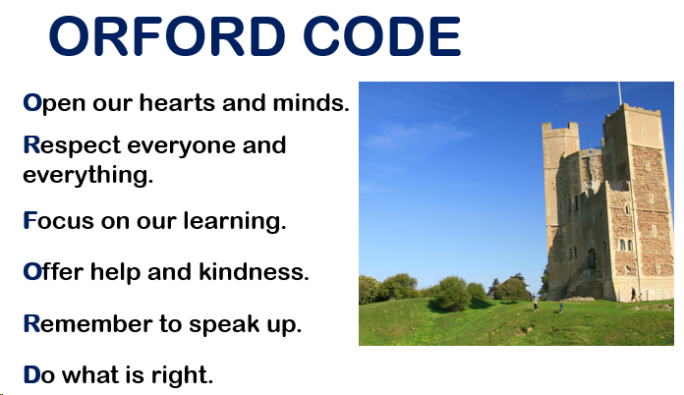
In school, we follow the ORFORD Code, which guides us to behave appropriately and treat each other kindly.

Relationships with children
Any relationship you have should be good and happy. A bad relationship might make someone feel scared, confused, worried and even unsafe.
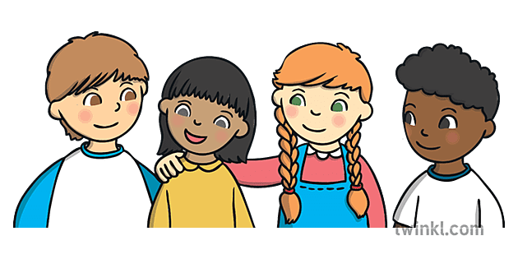
It’s really important that you know the difference between a good relationship and a bad relationship.

Good relationships
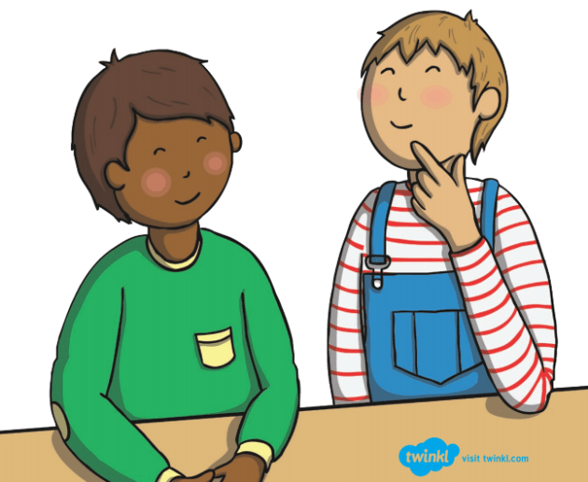
- You are comfortable around that person
- You can be honest with that person
- You can say how you feel, what you are thinking and you listen to each other
- You support each other and treat each other nicely
- You feel safe and trust that person
- You are equal – you don’t boss each other around or tell each other what to do frequently
- You feel looked after.
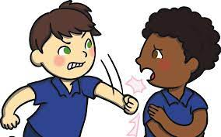
Bad relationships
- The person might push you, hit you or destroy your things
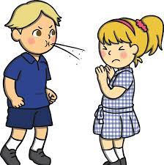
- The person might tell you what to do, what to wear or who you can see
- You might feel scared – they might say they will hurt you if you don’t do something
They might also say they will hurt you if you do something too.
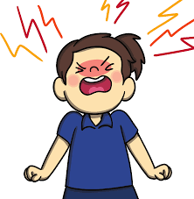
- The person calls you names, makes you feel bad in front of other people and makes you feel bad about yourself
- The person gets angry easily and you don’t know what will make them angry – it might make you feel nervous
- The person might make you to do things you don’t want to or aren’t ready for
- The person might not take no for an answer when you say you don’t want to do something
What is child-on-child abuse?
A child is someone who might be your friend, a child at school with you,
or another child you may know.

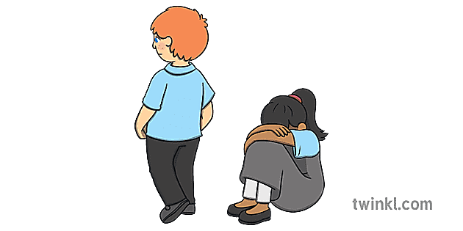
Abuse is something which physically or emotionally hurts another person by using behaviour that is deliberately meant to scare, hurt or upset that person.

Sometimes it can be hard to know when abuse is happening because not all abuse will hurt, scare or upset you, and you might not know it is happening.

It’s really important you know when you are being abused so we can make sure it stops.

There are lots of different types of abuse. It is important you know what these types of abuse are so you know what to do if you see them.
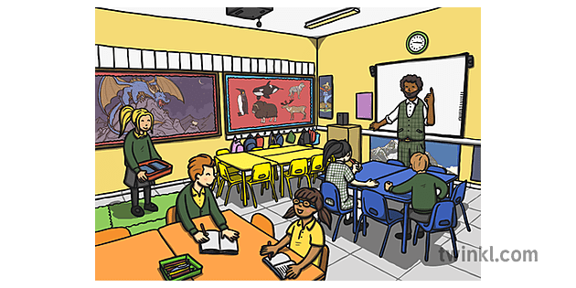
Type 1: Bullying
Bullying is when someone does hurtful things on purpose to another person.
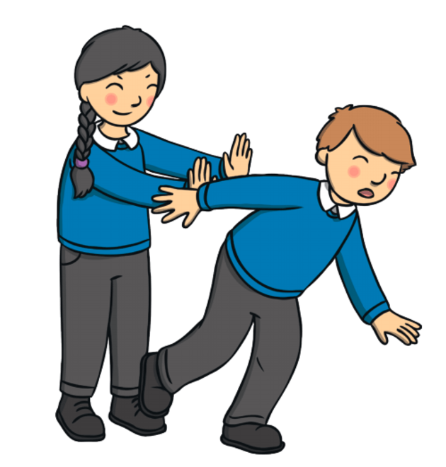
Physical bullying is punching, kicking, spitting, hitting or pushing someone.
Emotional bullying is hurting someone’s feelings, leaving them out or bossing them about.
Verbal bullying is teasing someone, calling them names or using rude hand signs.
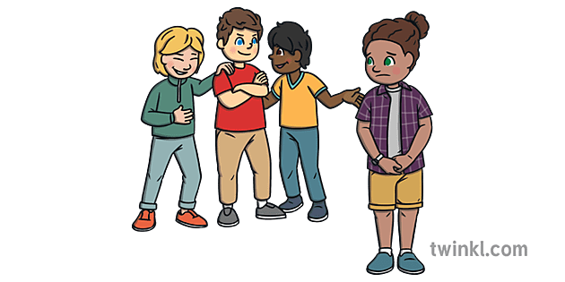
People also use verbal bullying to be racist or homophobic.

Racist means bullying someone because of their skin colour, race or what religion they believe in.

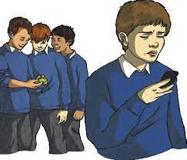
Homophobic means bullying someone because of their gender or sexuality; calling someone ‘gay’ or ‘lesbian’ to hurt their feelings would be homophobic.

Sexist means bullying someone because of their sex (whether they identify as a boy or a girl or inbetween).

Cyber bullying (online bullying) involves sending
horrid messages over the internet or by text message.

Bullying can be done by one person encouraging
another person to say or do nasty things.

Type 2: Sexual harassment
Sometimes you can be made to feel uncomfortable by people saying things or sharing things about private parts.

This can happen online, on social media, through messages and face-to-face. It might make someone feel scared, embarrassed, uncomfortable or upset.

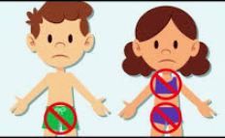
It could be:
- Someone saying rude things about someone’s appearance or clothes
- Calling someone names by referring to their private parts
- Jokes about your private body parts

Being physical, like touching which makes you feel uncomfortable, messing with your clothes, or showing pictures or drawings of private parts.
Type 3: Sharing nudes/semi-nudes

This is sending or viewing inappropriate pictures, videos or messages about private parts. They can sometimes be called ‘nude pics’, ‘rude pics’ or ‘nude selfies’, but can also be rude messages.

Encouraging someone to send these pictures, videos and messages is abuse.

Even if you are not the person who is sending them, it is illegal to have these kinds of pictures or videos of a person if they are under 18 years old. This means the police may become involved and will need to investigate what has happened.
How do I know if someone is being abused?
It might be hard for you to know if you are being abused and you might not really understand it is happening. It is important you can recognise when behaviour isn’t appropriate.

It’s also important that you can notice when someone else might be being abused.

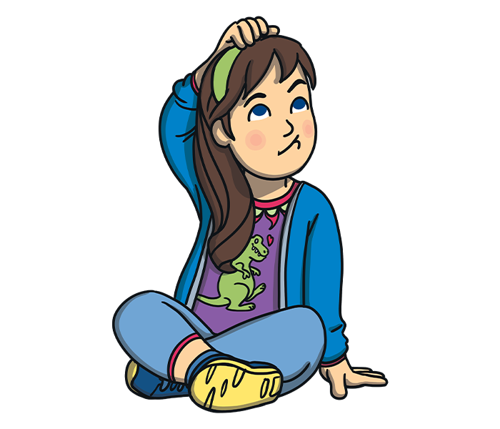
Some signs might be:

- Not going to school
- Having injuries, like bruises
- Feeling sad
- Feeling like they can’t cope
- Feeling withdrawn or shy
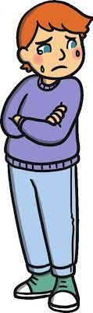
- Getting headaches or stomach ache
- Feeling nervous
- Not being able to sleep, sleeping too much or getting nightmares
- Feeling panicked
- Changing looks to look much older
- Being abusive to someone else.


Remember: you can feel all of these things too. Listen to how you feel,
and know that these signs might mean that you are being abused.

What do I do if I am being abused?
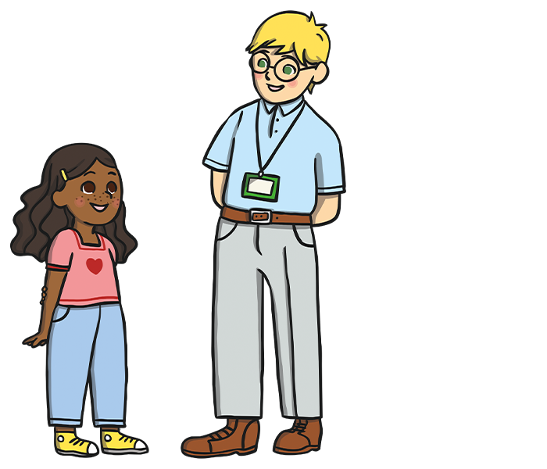
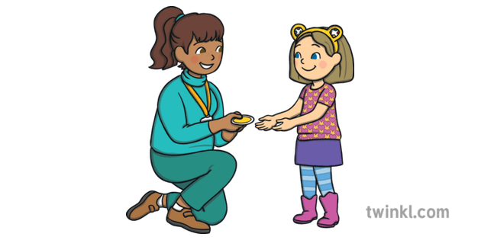
The first thing you should do is tell someone you trust. This could be any grown-up at school, a family member, or a friend.

You can also tell the person abusing you to leave you alone. If telling them to leave you alone would make you feel too scared or worried that they might hurt you, make sure you tell someone so that they can help.

Always remember that if you are being abused, it is not your fault and you are never alone.
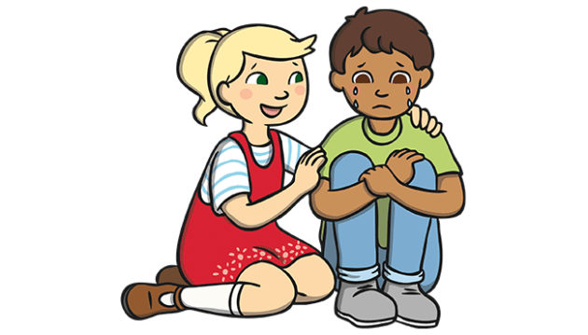

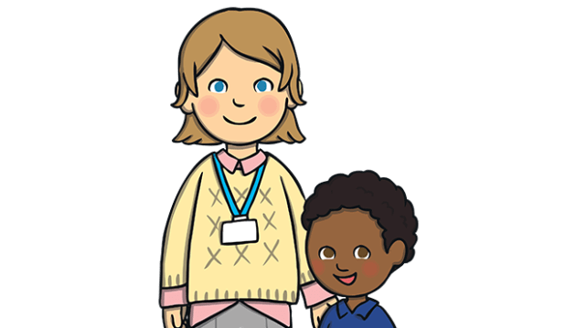
You shouldn’t be scared to talk to someone if you are being abused. If you talk to a grown-up, we can make the abuse stop.

What do I do if I think or know someone else is being abused?

If you see someone else being abused, it is important that you help that person.

You should never walk away and ignore the problem if you see someone else being abused because they need your help.

If you can, and it is safe to do so, tell the person to stop but never get angry or hit them.

Tell a grown-up, such as a teacher or teaching assistant, as soon as you’ve seen someone being abused.

You might worry that this could make the situation worse, or the person abusing may threaten to do something more harmful. This is not ok and is also abuse. You should never feel scared to tell someone about abuse.

Grown-ups can stop the abuse and make that person feel happy again.

Sometimes you might not see someone being abused, but you might be worried about them. Or, you might think they are being abused by someone you don’t know, or someone they have told you about.

It’s really important you tell someone if you are worried about someone else.

You should know that abuse is not funny, or part of growing up. Abuse is never OK and it is serious.
Who can I talk to?

It is important to tell someone as soon as you are being abused, or you notice someone else being abused.

Speaking to someone like your mum, dad, carer or any grown-up at school will mean that we can make sure the abuse stops and doesn’t happen again.

At school, you can speak to:

- Miss Cannon or Mrs McCart

- Your teacher or teaching assistant

- Carol or Jeff

- Any grown-up in school you feel safe to talk to

You could also call…
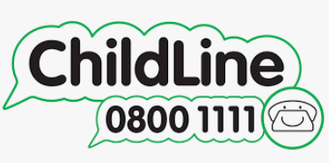
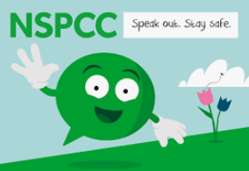

NSPCC: 0808 800 5000

